**WRITE THE TITLE HERE**

Author A. Name1*, Author B. Name1,Author C. Name2, Author D. Name1

1 Institution 1 Name, City, Country.

2 Institution 2 Name, City, Country

*Corresponding author email: correspondingauthor@email.com

1. INTRODUCTION

In this section, please provide a concise overview of your research or work, highlighting its significance and relevance to the themes of the area. Ensure that your introduction addresses the rationale for the study, background of the research area and objective and hypothesis.

**The total paper length, inclusive of graphics, figures, and references, should not exceed two pages.** Maintain the current document formatting without alterations. Ensure consistent margins of 1.7cm on all sides. When citing references indirectly in the text, utilize numerical brackets [1]. For direct references, employ the last name of the first author without initials, followed by the reference number in brackets. If there are multiple authors, use the first author's name followed by et al. and the reference number in brackets.

1. MATERIALS AND METHODS

This section requires a comprehensive depiction of the materials and methodology applied in your research or project. Its significance lies in enabling a thorough evaluation and understanding of your research contributions. Emphasize clarity and transparency to facilitate the reproducibility of your work.

Clearly list and describe all materials, tools, equipment, and software used in your study. Outline the design of your experiment or study. Detail the procedures and steps followed, ensuring that the reader can replicate your methodology. Specify any controls or variables manipulated during the investigation.

Clarify the statistical or analytical methods used to interpret your data. If your research involves human subjects, animals, or sensitive data, provide information on ethical approvals obtained and steps taken to adhere to ethical standards.

1. RESULTS AND DISCUSSION

The results are presented in this section, along with a discussion on the relevance of the work to the research area. Tables and Figures must be labeled with Arabic numbers (e.g., Table 1, Table 2, Figure 1) in the sequence in which they are cited and should be inserted as closely as possible to the corresponding references in the text. A sample of the appropriate table format is exemplified in Table 1 and Figure 1.

Table 1 – Title of table 1.

|  |  |  |  |  |
| --- | --- | --- | --- | --- |
| Traits | Growth rate | | Pr > F | |
| Factor 1 | Factor 2 | Factor 1 | Factor 2 |
| Carcass weight, kg | 249 | 293 | <0.001 | 0.070 |
| Backfat thickness, mm | 4.87 | 4.78 | 0.788 | 0.574 |
| 24h carcass pH | 5.59 | 5.58 | 0.192 | 0.136 |
| 24h carcass temperature, oC | 6.42 | 7.12 | <0.001 | 0.871 |

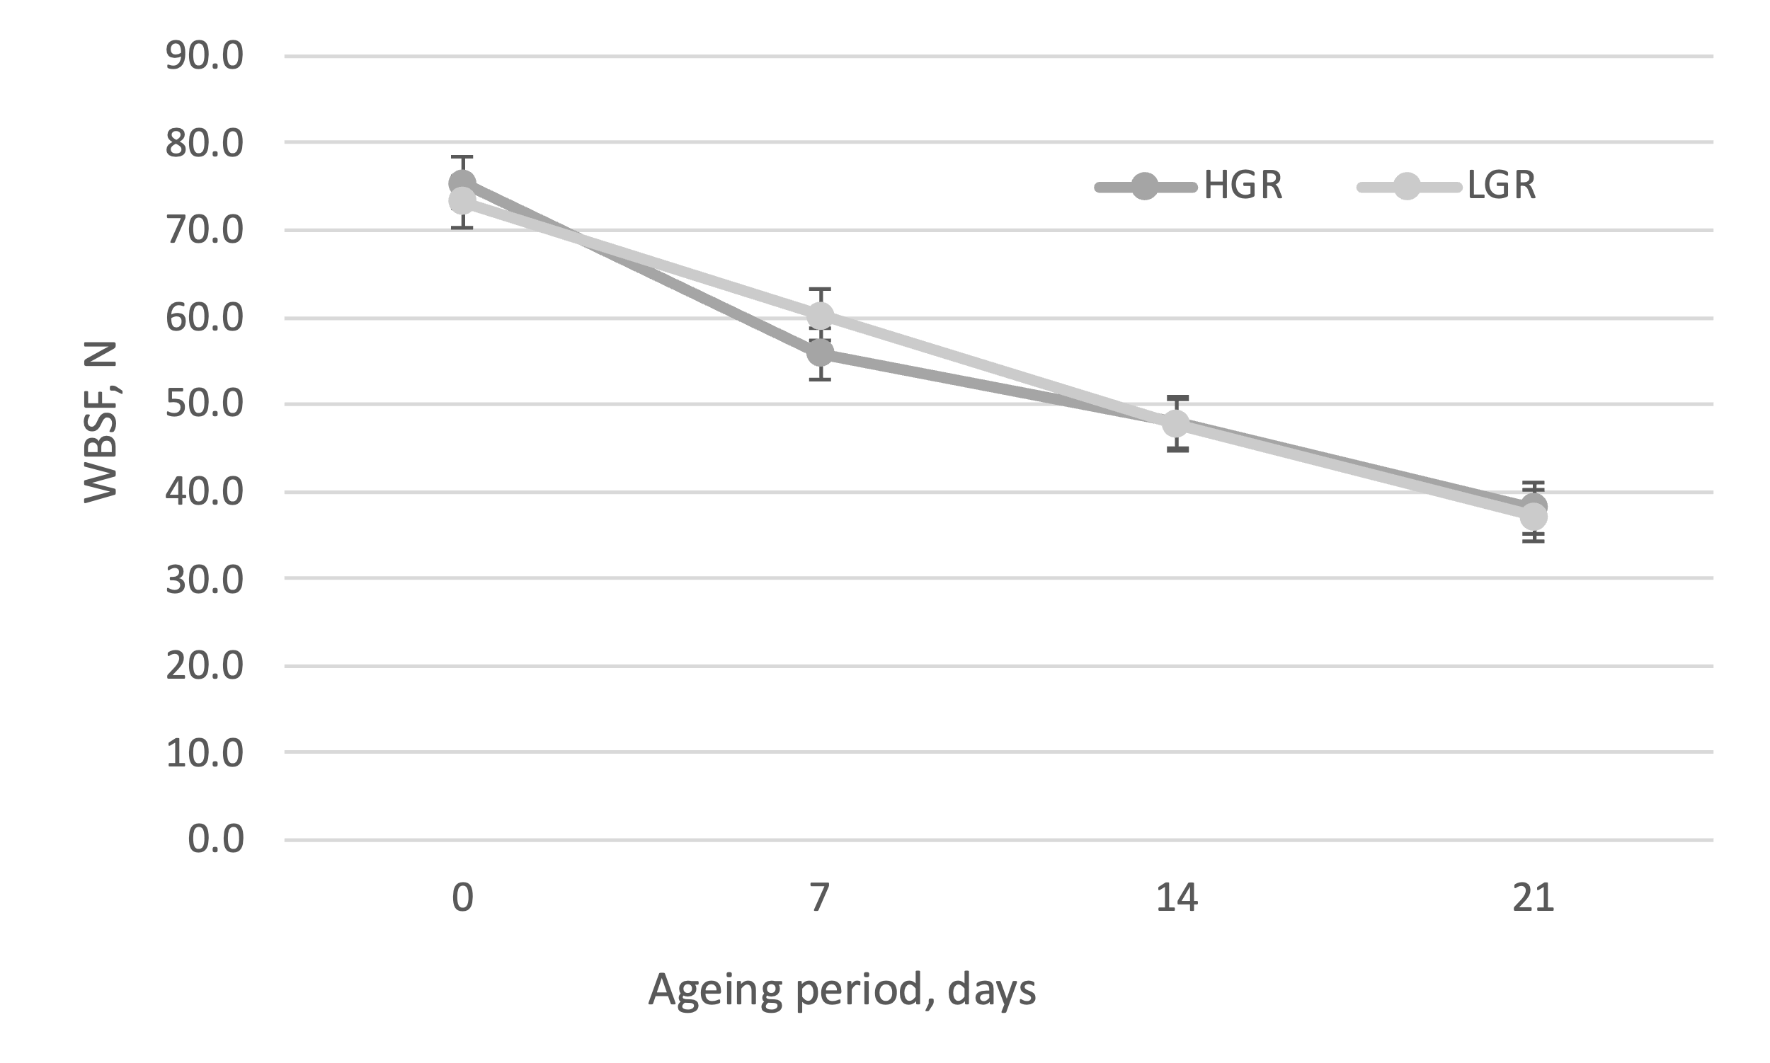

Figure 1. Title of Figure 1

1. CONCLUSION

In this section, summarize the key findings and insights derived from your study, providing a concise overview of the contributions to the field. If applicable, encourage further exploration by proposing avenues for future research. Identify questions or areas that remain unexplored, hinting at the potential for continued investigation.

ACKNOWLEDGEMENTS

If your research received grants or funding, acknowledge the sources appropriately, including grant numbers or project names associated with the financial support.

REFERENCES

References should be arranged numerically by order of appearance in the following format:

*Papers:*

1. Thompson, J. (2002) Managing beef tenderness. Meat Science, 62: 295-308.
2. Seideman, S. C.; Cross, H.R.; Oltjen, R.R.; Schanbacher, B.D. (1982) Utilization of the intact male for red meat production: A review. Journal of Animal Science 55: 826-839.

*Book:*

1. Gerrard, D.E. (2006). Principles of animal growth and development. Wallingford & New York: Kendall/Hunt Publishing Company, 264p.

*Proceedings:*

1. Muguruma, M., Tsuruoka, K., Fujino, H., Kawahara, S., Yamauchi, K., Matsumura, S. & Soeda, T. (2021). Meta-analysis of the relationship between collagen characteristics and beef tenderness (pp. 34), August 2021, Kraków, Polland.

*Book Chapter:*

1. Suman, S. P., Ramanathan, R., Nair, M.N. (2022). Advances in fresh meat color stability. In Purslow, P., New Aspects of Meat Quality - From Genes to Ethics (pp 139-161). Cambridge: Woodhead Publishing.

*Web References:*

Include the complete URL address, along with any available information such as author names, publication date, and reference to the source publication. Web references can be presented separately or incorporated into the reference list.